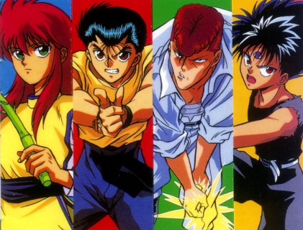
Episode 5
Yu
Yu
Hak
usho
Forgiveness for Words

“Aikou” Yusuke said with sorry in his voice. “I didn’t mean to tell off you’re tribe. I was putting it into simpler words to understand.”
“For what you have said is unforgivable Yusuke!” Yami said with rage. “Does anyone else want to bad mouth my tribe?” said Aikou in anger.
Muzi Suki stepped forward. “Aikou”
“What do you want?” Yami glared at her.
“What I think Yusuke meant was” before Muzi could finish her sentence Yami interrupted her “Just shut up non of you guys understand what I’m going through non of you.” With that Aikou stormed out of Kuwabara’s house with out saying another word.
“What do you think is wrong with her?” Kuwabara asked, “We were trying to give her forgiveness.”
“Kuwabara if only you could understand Youkos.” Kurama said. “Then you could give her the forgiveness that she needs.”
“Kurama” said Muzi “Maybe you should talk to her. You are the only other Youko here it would probably make her feel better that it is coming from you.”
Kurama looked at her for a moment then said, “Yes you are right I will go and talk to her.” Kurama turned towards Yusuke, “Is there anything that you want to tell her Yusuke?”
“Yes Kurama tell her this I didn’t mean to insult her tribe or your guys race. I was putting it into simpler terms so it wouldn’t be to confusing.”
“Kurama can you give her a message from me?” asked Botan
“What is it?”
“Tell her it is going to be all right and we will help save the Youkos.”
“I will she will be glad to know that.” Kurama ran out the door to go find Aikou Yami with all the Rei Kai Tantei hoping that Kurama can convince Yami what Yusuke said was just a big mistake.
“Don’t worry about the Kitsune.” Hiei took a pause. “He will be able to convince Yami that Yusuke made a mistake. He has a way with words that no one else in this room does.”
“I hope so I don’t want Yami made at me, because we are the ones that have to save her.”
“You are so right Urameshi.” Added Kuwabara.
“Don’t worry we all believe Kurama he will make Yami understand.” Said Muzi.
“You are so right sis.” Said Botan

Outside

“ YAMI, YAMI!” Kurama shouted. “I’m never going to find her.” Just then Kurama seen Yami sitting on a bench crying, he walked up slowly and sat on the bench with her. “Yami” Kurama said.
Yami looked up to see the face of the other Kitsune smiling down at her. “Y-e-s” she finally managed to say between snobs.
“Yami will you listen to me.”
“Yes.”
“What Yusuke was trying to say is.”
“If you are going to speak about that moron I don’t want to hear it.”
“You told me you would listen.” Kurama turned and look directly in her eyes. “Now understand this Yami what Yusuke said is that he wanted to put it in simpler terms so he could understand the mission.” Kurama paused “He didn’t mean to insult your tribe.”
“Well coming from you makes me feel better about it.” Yami said this as she scouted over towards Kurama. “You always make me feel better about things Youko Kurama.”
Kurama look down at her and smiled, he never took a good look at her face in tell now. He notices how incredibly pretty she was up until now. “Yami.”
“Yes Kurama?”
Kurama put his arms around her body and pulled her close. They stared into each other’s eyes. Until their lips met it was a short kiss put a very passionate one. When Kurama lifted his face away from Yami’s lips he kissed her on her cheek. He pulled away from even further and took a look at her now. Her cheeks were all flush with color. Kurama knew he took her from surprise but she liked it.
“Kurama if you were going to do that you should have told me.”
“The first kiss is always the surprise one remember that.”
“I will I love you my Youko.”
“Same here.”
“I have a request Kurama.”
“Yes.”
“Can I see your Youko form?”
“Just as long as I can see yours deal?”
“Deal.”
With that the two Kitsune’s transformed into they’re full demon form. They stared at each other for a little while.
“Yami it’s like looking into a mirror.”
“Same here.”
“We have the same color fur to weird.”
The two Kitsune’s turned back into they’re human forms. “Are you ready to go back and join the other Rei Kai Tantei Yami.”
“Yes I will forgive Yusuke Urameshi all thanks to you.”

