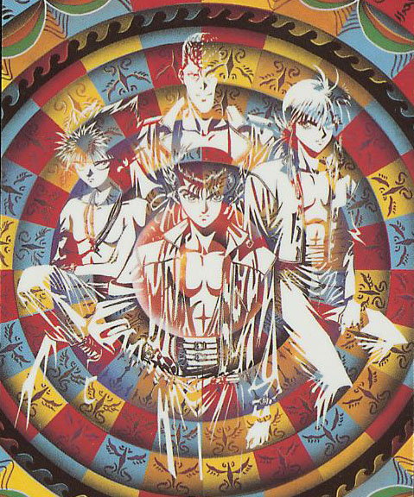
Episode 2
Y
U
Y
u
H
a
k
u
s
h
o
Aikou Yami a Youko?

Kurama was certain that the he kai was coming from her. She turned and looks at the handsome red head. She was sensing and kai like hers from him.

“Hello.” This cheering girl said, “My name is Aikou Yami. I just moved here a couple of days ago.

*She seems cheery to be a Youko* “Hello my name is Shuuichi Minamino. I will be showing you around school today.”

“I will be honored if you showed me around. Let me guess do all the girls like you at this school?”

“How could you guess that answer.”

“You so cute Shuuichi.”

He didn’t answer her, the kai that she was admitting was so strong. Kurama was wondering if she could fell his kai too.

“How come you are not answering me Shuuichi?”

“I’m sorry I was just thinking. I went off into my own little world.
“I do that often, so who are your friends here?’

“Lets walk around the school, when I finish showing you around I will tell you about my friends deal?”

“Sure.”

As Kurama was walking Aikou around the school he was beginning to wonder what her Youko form looked like if she was even a Youko, and if she was wondering the same.

At Sarayashiki Junior High Yusuke was on the rooftop on the school talking to his rival Kuwabara.

“So Yusuke do you think we will be going on any missions soon?”

“How in the hell and I suppose to know! Koenma hasn’t said a word.”

“Well you don’t have to be rude about it Urameshi! I just asked a question.” Kuwabara yelled back at Urameshi.

“I know Keiko treating me like shit.” Yusuke said calming down.

“Yukina has just been as sweet as always. Maybe you need to stop skipping like we are doing now or stop being a smart ass and talk to her Urameshi.”

“Maybe you’re right Kuwabara, I should talk to her.” Just then a black cloak half-pint jumped in front of Yusuke and Kuwabara.

“Hey look its half-pint.”

“Shut up Kuwabara.” Yusuke said, “What do you need Hiei.”

“Your ugly loud mouth friend interrupted me.” Hiei said.

“Who’s ugly.” Kuwabara asked.

“You are who else.” Hiei shot back. “I came here to tell that we are going to go on a mission.” Hiei said while walking up to Kuwabara and Yusuke.

“Who’s orders, I didn’t get any information from Koenma.” Yusuke shot back at Hiei, Kuwabara just watching the two black head talk.

“Of course you didn’t get any info you dolt I didn’t get my information from Koenma.”

“Hiei” Kuwabara asked, “Who told you this?”

“Why should I tell you stupid human?”

“Well maybe I’m part of the Urameshi Team too?”

“Guys lets stop fighting.” Yusuke demanded, “Hiei tell us who told you that we are going to go on a mission.

“Kurama” said Hiei

“Did Kurama get any info from Koenma.” Asked Yusuke.

“No he felt a Youko kai at his school.”

Kuwabara interrupted “Hiei you know that isn’t true because Kurama is the last Youko.”

“Don’t interrupted me again or I will stick this sword up you ass to where I won’t be able to pull it out myself.”

Kuwabara didn’t say another word he was stone stiff and couldn’t move, because he knew that Hiei meant his word.

“As I was saying I know that he is the last Youko but that isn’t true because Kurama sensed the kai the himself which happens to be the same as his.” Hiei glared at Kuwabara who was still stone stiff. “So we sensed the Youko coming from the Kitsune’s school.”
“Really Hiei, if that is the case we have to find out who this mysterious Youko is.” Yusuke said.

“Right we better get on it.” Kuwabara said.

“My point exactly.”

And the three jumped of the school’s roof top and headed towards Kurama’s school.

